The Fundamentals - Setting Up our Database Filemaker Pro 5.0

When you finish this training on the fundamentals, you will have created a database solution consisting of a linear database and possibly one relational database all working together to create a customers database.

Later you will learn relationships, look-ups, calculations, scripting, drop-down lists, summary fields, summary reports, portals, file sharing, networking and more.

1. First we'll create a database. A database is a file. Within your new file you will have individual records that each contain different fields for storing different information.
like- first name, last name, address etc.

- Start Filemaker Pro

- Click on Create a new Database
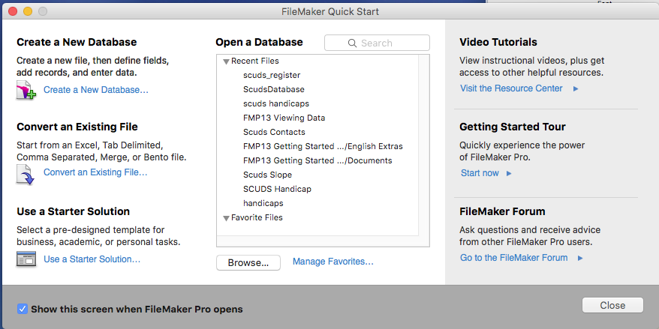

- Save as filemaker100.fp12 to your folder.

Filemaker Pro 12 Window ready to enter fields

After saving your filename "filemaker100.fp12" you will see the field definitions window below

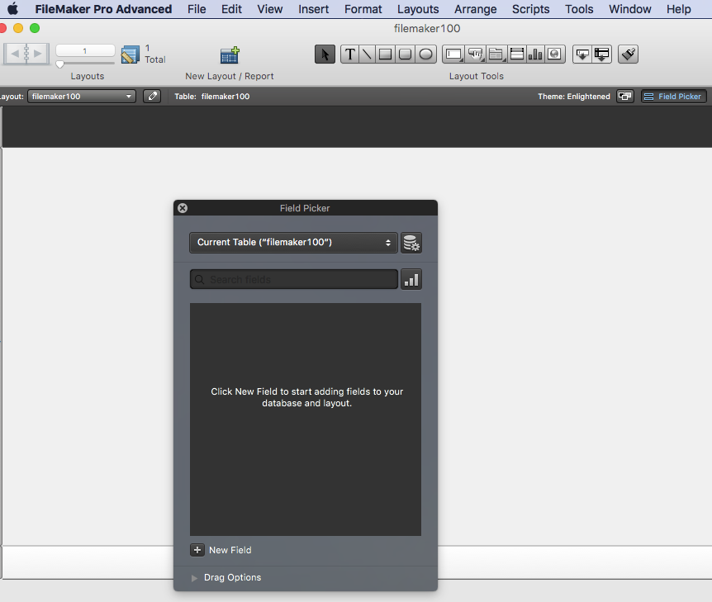

. Lets create all the fields we will

Type in "First Name" leave the radio button below it set to "Text" and click on create.

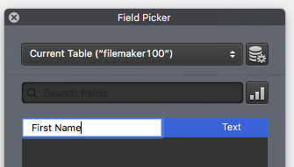
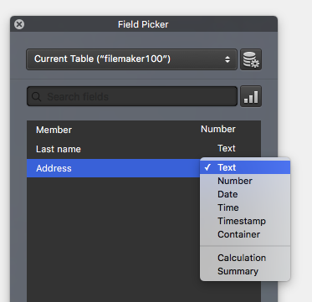

Type Member (make this Number)
"Member".

Now enter a field that will be our key or primary key.

This will be our member number

Go to Manage Database and select Member

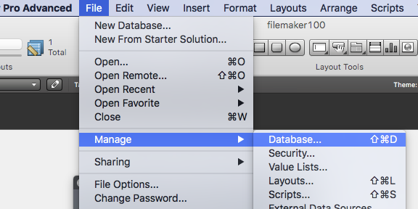

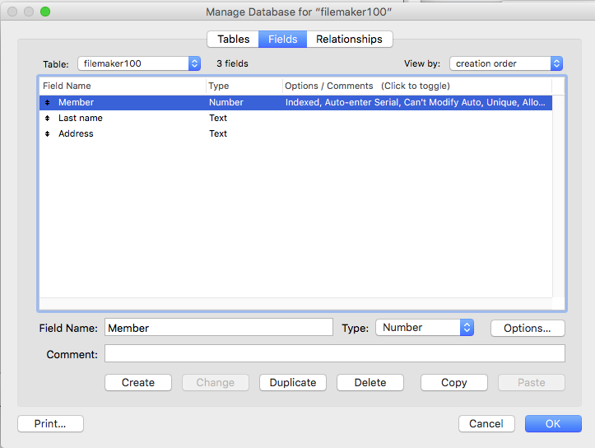

Click on Options

We now need a unique field for
member field
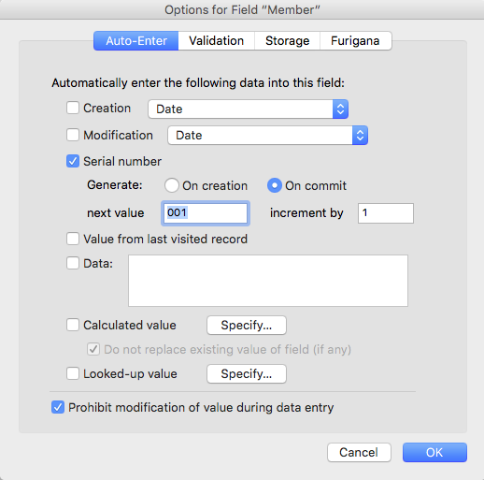
- From the manage database open
- click on field Member

- Click on the Options button
- This will take us to this Window

- Click Serial Number and set
- The number to 001

- Click Prohibit modification
- of value

- Click OK

- Then click "Done"

You will now see the database in basic entry mode.

Date of Birth find the Age Today (Select Age Today)
Paste the following into the Calculation box.
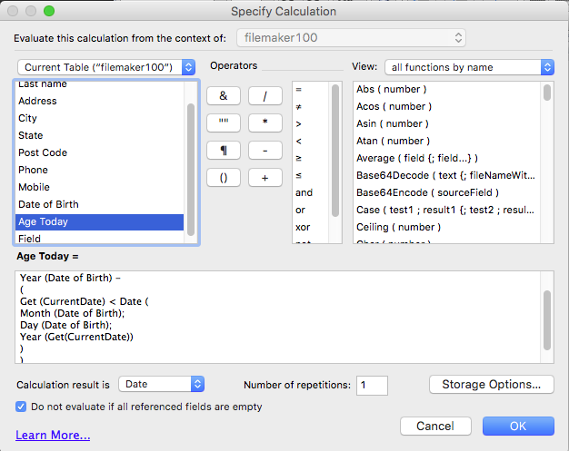

PASTE THE FOLLOWING IN

Year (Get(CurrentDate)) -
Year (Date of Birth) -
(
Get (CurrentDate) < Date (
Month (Date of Birth);
Day (Date of Birth);
Year (Get(CurrentDate))
)
)

Manage Database
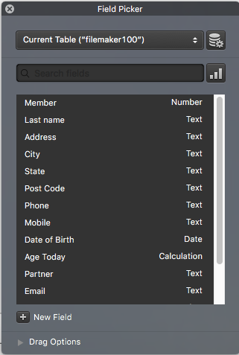

All remaining should be Text fields.

Now repeat the process for
"Last Name",
"Address",
"City",
"State",
"Post code",
"Phone"

later we will Insert a calendar

If we have forgotten a field go to Manage Database and create a new field (We need a First Name field)

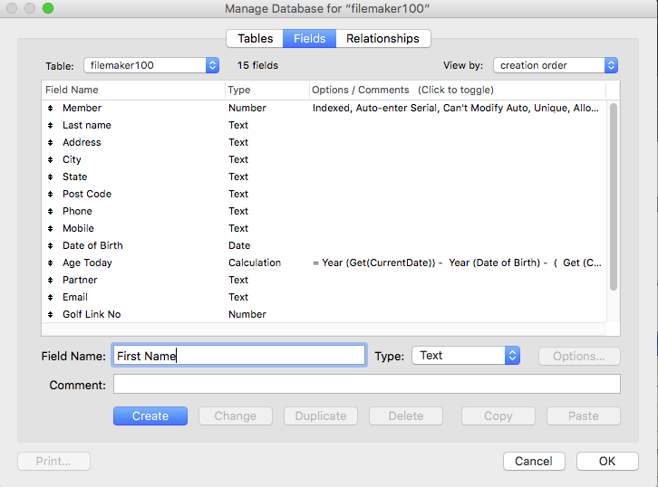

Click the field insert toolbar and drag a field onto the window

Click the name to attach to that field
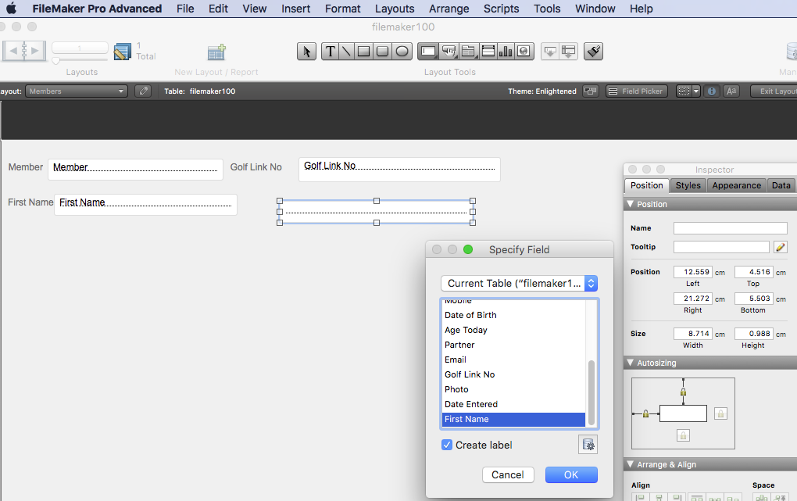

Now we need to edit our layout in Layout mode click on View and show Toolbars Text Formatting, Tools and Arrange toolbars.
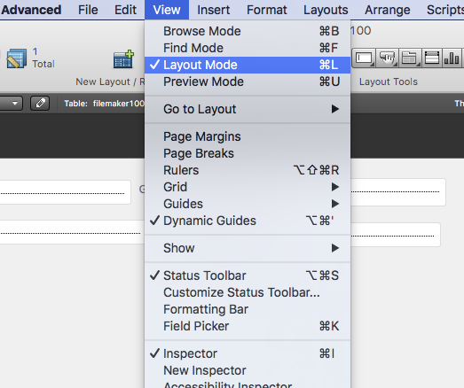

For Date of Birth insert a drop down Calendar
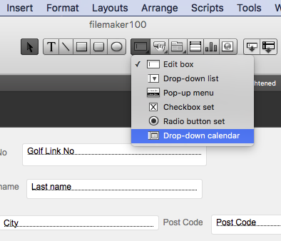

Insert a Drop Down List Call this membership
Name this and then edit the drop down list

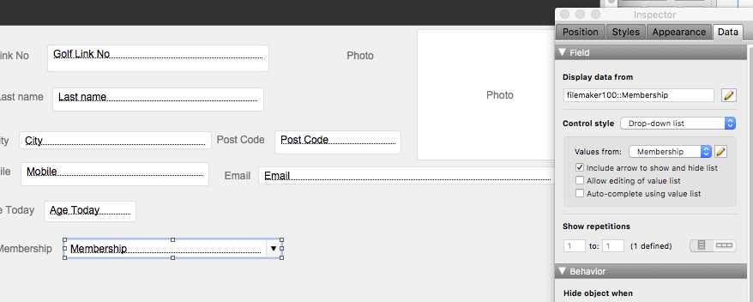
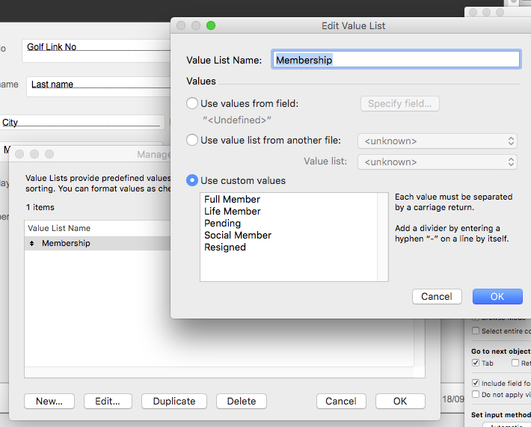

You can now alter the placement of your database add colours to fields and add buttons

Play with your design and create a unique database for your company

Next we will import some data and add our new customers

This ends this session

Prepared by Peter J Faulks

